Student worksheet

7.1 Displacement is change in position with direction

Pages 156–157

Distance and displacement

1 Complete the second column of the table below, showing your understanding of the key terms on the left. Once you have finished, discuss with a peer, recording their understanding in the third column. Finally, check your answers with your teacher or the Student book by using the glossary at the end.

|  |  |  |  |
| --- | --- | --- | --- |
| Key term | My understanding of this word | My peer’s understanding of this word | Actual definition |
| Distance |  |  |  |
| Displacement |  |  |  |
| Scalar quantity |  |  |  |
| Vector quantity |  |  |  |

A girl riding her skateboard completed the journey shown by the graph below.

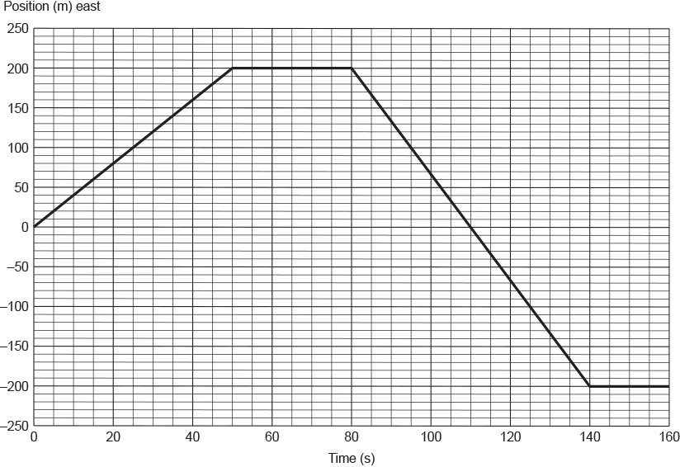

2 Describe the girl's motion as indicated by each of the different sections on the graph.

|  |
| --- |
|  |
|  |
|  |
|  |
|  |

3 How far did the girl travel in 160 seconds? Give your answer in metres.

|  |
| --- |
|  |

4 What was the girl’s displacement at each of the following times?

a t = 50 seconds

|  |
| --- |
|  |
|  |

b t = 110 seconds

|  |
| --- |
|  |
|  |

c t = 150 seconds

|  |
| --- |
|  |
|  |

5 What does the shape of the graph between t = 0 and t = 50 seconds suggest about the girl’s motion? Explain your answer.

|  |
| --- |
|  |
|  |
|  |
|  |

A brother and sister arrived with their parents at a hotel that, below the foyer on the ground floor, had three levels of underground car parking. Above the foyer were 12 floors of guest rooms. While their parents were checking the family into the hotel, the two siblings snuck off to ‘ride’ in one of the lifts. From the hotel foyer, they rode the lift up 9 floors, then down 11 floors, up 5 floors and finally down 5 floors.

6 On which floor did the two siblings finish their elevator ride?

|  |
| --- |
|  |

7 How many floors did they pass through on their journey?

|  |
| --- |
|  |

Extend your understanding

From a campsite, a hiker walked 12 kilometres north and 5 kilometres west. She then walked 4 kilometres south and 20 kilometres east.

8 In the space provided below, carefully draw the journey taken by the hiker. Use a scale of 0.5 centimetre = 1.0 kilometre. Draw a line from the hiker’s campsite to where her journey finished.

|  |
| --- |
|  |

9 Without using a ruler or protractor, determine the hiker’s final displacement.

|  |
| --- |
|  |

Student worksheet

7.2 Velocity is speed with direction

Pages 158–159

Speed and velocity

1 Explain in your own words, the difference between speed and velocity.

|  |
| --- |
|  |
|  |

2 Use the formula triangle to identify the following formulas.

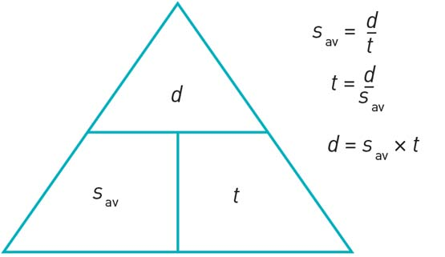

a Distance

|  |
| --- |
|  |

b Time

|  |
| --- |
|  |

c Average speed

|  |
| --- |
|  |

3 Use the formula triangle to identify the following formulas.

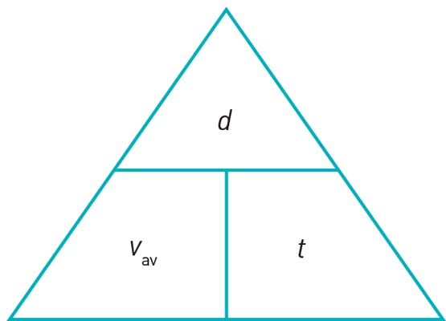

a Displacement

|  |
| --- |
|  |

b Time

|  |
| --- |
|  |

c Average velocity

|  |
| --- |
|  |

4 In 2009 Usain Bolt set a new world record time of 9.58 seconds for the men’s 100 metres. What was his average speed for the race? Give your answer in metres per second.

|  |
| --- |
|  |

5 Kenyan athlete Daniel Komen holds the world record for the men’s 3000 metres. If his average speed for the race was 6.81 m s–1, what is his world record time? Give your answer in minutes and seconds.

|  |
| --- |
|  |

6 What was the total distance travelled by an object whose velocity–time graph is shown below? Give your answer in metres.

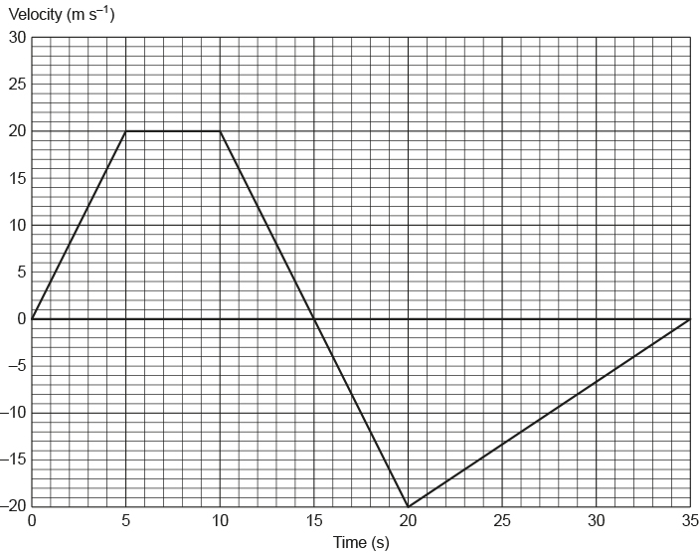

7 What was the average speed of an object whose velocity–time graph is shown in Figure 3? Give your answer in metres per second.

|  |
| --- |
|  |

8 What was the final displacement of the object after 35 seconds? Give your answer in metres.

|  |
| --- |
|  |

9 What was the object's average velocity during the 35 seconds?

|  |
| --- |
|  |

Extend your understanding

This graph shows the motion of a man riding on a Segway along straight pathway.

|  |  |
| --- | --- |
| L:\1. Publishing and Editorial\1. Product\Oxford Science\Oxford Science 10\3. Extras\6. Student worksheets\Artwork\4. Final jpgs\SW0706_01095.jpg | L:\1. Publishing and Editorial\1. Product\Oxford Science\Oxford Science 10\3. Extras\6. Student worksheets\Artwork\4. Final jpgs\SW0707_01095-rf.jpg |

10 Which of the options, P–S, correctly describes the man’s motion in each of the stages AB, BC, CD and DE, as shown by the graph?

|  |  |  |  |  |
| --- | --- | --- | --- | --- |
|  | AB | BC | CD | DE |
| P | Decelerating | Constant speed | Accelerating | Stationary |
| Q | Accelerating | Stationary | Constant speed | Decelerating |
| R | Accelerating | Constant speed | Decelerating | Stationary |
| S | Decelerating | Stationary | Constant speed | Accelerating |

|  |
| --- |
|  |
|  |
|  |
|  |
|  |
|  |
|  |

11 What was the man’s average speed during section AB? Give your answer in metres per second.

|  |
| --- |
|  |

12 What was the man’s speed during section BC? Give your answer in metres per second.

|  |
| --- |
|  |

Student worksheet

7.3 Acceleration is change in velocity over time

Pages 160–161

Acceleration – speeding up and slowing down

1 What is acceleration?

|  |
| --- |
|  |
|  |

2 Imagine that a marble is rolling along a table. List two ways that you could:



a change its speed but not its direction

|  |
| --- |
|  |
|  |

b change its direction but not its speed.

|  |
| --- |
|  |
|  |

3 The speed–time graph below shows an object travelling at constant speed before decelerating. In the space provided, draw another speed–time graph that shows an object accelerating before beginning to travel at a constant speed.

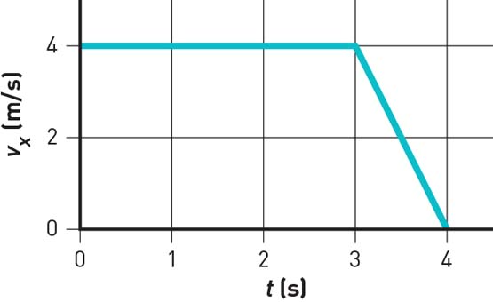

|  |
| --- |
|  |

4 What is the average acceleration of a car that, from rest, reaches a speed of 27.8 m s–1 (100 km h–1) in a time of 4.6 seconds? Give your answer in metres per second per second.

|  |
| --- |
|  |

5 What would be the final speed of a car initially travelling at 72 km h–1 if it accelerated at 1.25 m s–2 for 4.0 s? Give your answer in kilometres per hour.

|  |
| --- |
|  |

Extend your understanding

The graph below shows a journey made by a tram as it travelled along a straight stretch of track. The mass of the tram and its occupants is 25 000 kg.

|  |  |
| --- | --- |
| L:\1. Publishing and Editorial\1. Product\Oxford Science\Oxford Science 10\3. Extras\6. Student worksheets\Artwork\4. Final jpgs\SW0711_01095.jpg | L:\1. Publishing and Editorial\1. Product\Oxford Science\Oxford Science 10\3. Extras\6. Student worksheets\Artwork\4. Final jpgs\SW0710_01095-r.jpg |

6 What was the tram’s acceleration at t = 20 seconds? Give your answer in metres per second per second.

|  |
| --- |
|  |

7 What was the tram’s acceleration at t = 140 seconds? Give your answer in metres per second per second.

|  |
| --- |
|  |

8 How far did the tram travel in the 150-second interval? Give your answer in metres.

|  |
| --- |
|  |

Student worksheet

7.4 An object in motion remains in motion until a force acts on it

Pages 162–163

Newton’s first law: Inertia

1 Which of the two shopping trolleys shown in the diagram below has the greatest inertia? Explain your answer.



|  |
| --- |
|  |
|  |
|  |

2 The diagram below shows a stack of five coloured circular disks made of smooth, polished wood. Describe the motion of the coloured disks when the plunger is hit quickly and firmly by the hand.

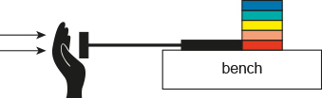

|  |
| --- |
|  |
|  |
|  |

3 The photograph below shows a 4.0-kilogram penguin sliding across a large, flat icy surface with a constant velocity of 2.0 m s–1. Assuming that the surface is frictionless, what size force is required to keep the penguin travelling at this speed?

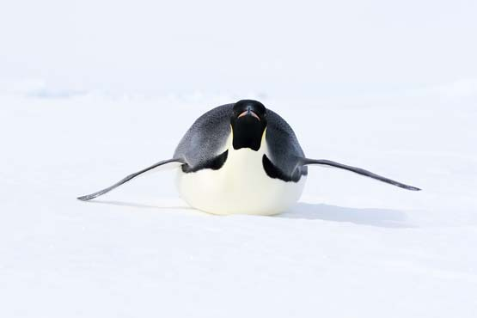

|  |
| --- |
|  |
|  |
|  |
|  |

4 In the diagram below, will the cyclist be travelling in a state of constant motion? Explain your answer.

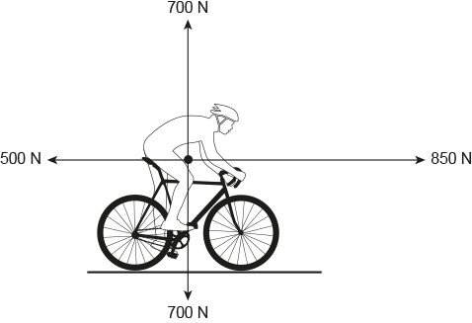

|  |
| --- |
|  |
|  |
|  |
|  |

Extend your understanding

5 Use your understanding of Newton’s law of inertia to explain how the cyclist got to the position he is in in the following photograph.

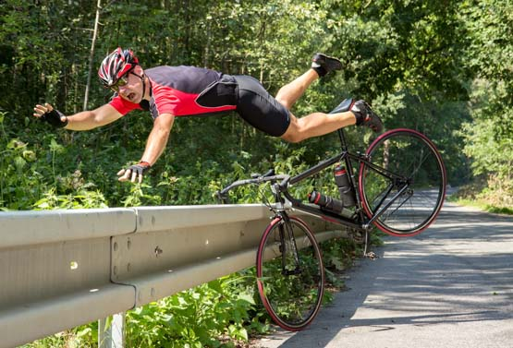

|  |
| --- |
|  |
|  |
|  |
|  |
|  |

6 Michaela took a ride on an amusement park ride called the ‘Space Shot’. At ground level at the start of the ride, Michaela said that she felt like she was being pushed very hard downwards into her seat – but that this confused her as she knew that she was moving upwards very quickly. Explain the physics of what Michaela experienced at the start of the ride.

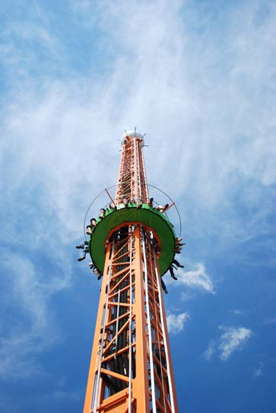

|  |
| --- |
|  |
|  |
|  |
|  |
|  |

Student worksheet

7.5 Force equals mass × acceleration

Pages 164–165

Newton's second law: Fnet = ma

1 Describe Newton’s second law.

|  |
| --- |
|  |
|  |

2 What is the difference between mass and weight?

|  |
| --- |
|  |
|  |

3 What formula can be used to calculate net force?

|  |
| --- |
|  |

4 Complete the equation triangle for net force below and describe how it works.

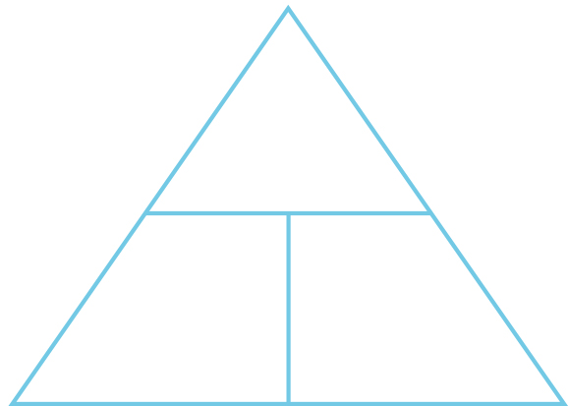

|  |
| --- |
|  |
|  |
|  |

Where necessary below, use g = 9.80 m s–2. Unit conversions: 1000 grams = 1 kilogram and 1000 kilograms = 1 tonne.

5 How much horizontal net force is required to accelerate a 1200-kg car at 1.5 m s–2?

|  |
| --- |
|  |
|  |
|  |

6 A net force of 16 N gives a bowling ball an initial acceleration of 2.5 m s–2. What is the mass of the bowling ball?

|  |
| --- |
|  |
|  |
|  |

7 A speed skater has a mass of 64 kg. She is providing a driving force of 400 N, and there is a frictional force of 240 N against her. Draw these two forces acting on her and then determine her acceleration.



|  |
| --- |
|  |
|  |
|  |

Extend your understanding

8 A skydiver of mass 85 kg is falling through the air at terminal velocity (constant speed).

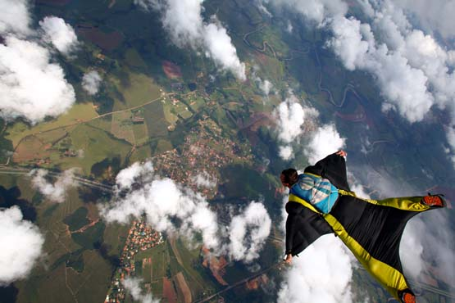

a What is the weight force acting on the skydiver?

|  |
| --- |
|  |
|  |

b How much air resistance is acting on the skydiver?

|  |
| --- |
|  |
|  |

9 The Airbus A380 has a mass at take-off of 575 tonnes. During take-off, its four engines provide a total thrust of 1300 kN. Its take-off speed is 270 km h–1 and it takes 72 seconds from rest to reach this speed.

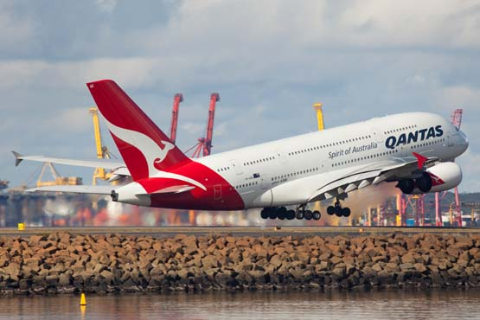

a What is the average acceleration of the A380 during its take-off run? Give your answer correct to two decimal places.

|  |
| --- |
|  |
|  |
|  |
|  |

b What is the average total resistive force acting against the A380 during its take-off run?

|  |
| --- |
|  |
|  |
|  |
|  |

Student worksheet

7.6 Each action has an equal and opposite reaction

Pages 166–167

Newton’s third law: FAB = –FBA

For each of the following four situations, describe the action and reaction forces. Remember that each force acts on a different item in the object pair.

|  |  |  |  |
| --- | --- | --- | --- |
|  | Situation | Action | Reaction |
| a | A rocket taking off from its launch pad.  SW0723_01095-r |  |  |
| b | A tennis racquet hitting a tennis ball.  SW0724_01095-r |  |  |
| c | A sprinter pushing off from the starting blocks.  SW0725_01095-r |  |  |

|  |  |  |  |
| --- | --- | --- | --- |
| d | A footballer marking a football.  SW0726_01095-rf |  |  |

Extend your understanding

6 A horse is pulling on a cart. If the cart exerts an equal and opposite force on the horse, how is it possible for the horse to pull the cart so that it moves? Use your understanding of Newton’s laws of motion to explain this situation.

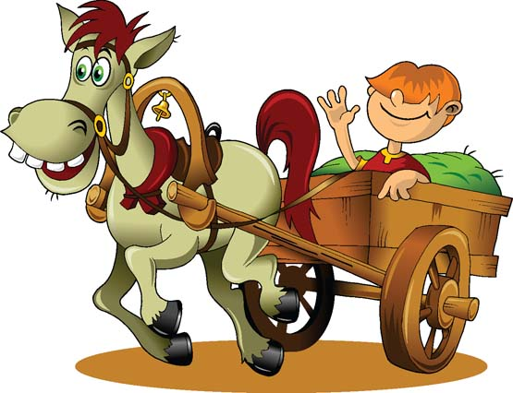

|  |
| --- |
|  |
|  |
|  |
|  |

7 The photograph below shows a stationary gymnast hanging from a set of rings. What is the reaction force to the action of the weight force acting on the gymnast? Explain your answer.



|  |
| --- |
|  |
|  |
|  |

Student worksheet

7.7 Momentum is conserved in a collision

Pages 168–169

Momentum

1 What is the law of conservation of momentum?

|  |
| --- |
|  |
|  |

2 Consider the image below of Newton’s cradle. When a ball from the left is lifted and then dropped, the collision will force a ball on the other side to rise. Using the law of conservation of momentum, explain why this is happening.



|  |
| --- |
|  |
|  |
|  |

3 What is the formula used to calculate momentum?

|  |
| --- |
|  |

4 For each of the following situations, calculate the size of the object’s momentum.

a A speed skater of mass 75 kg moving with a velocity of 5.8 m s–1

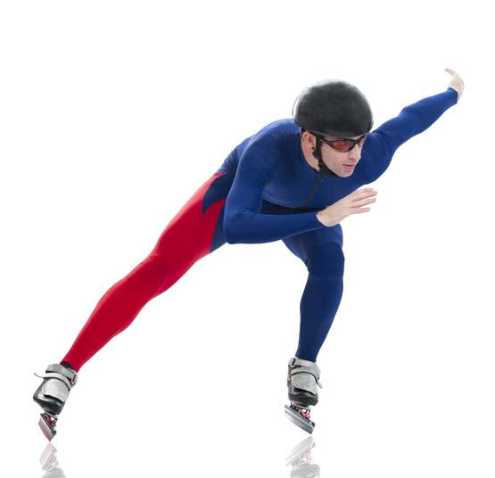

|  |
| --- |
|  |
|  |

b A tennis ball of mass 58 g travelling at 180 km h–1



|  |
| --- |
|  |
|  |

Extend your understanding

5 Jane and Christopher are performing a skating routine. Jane has a mass of 56 kg and Christopher has a mass of 84 kg. Before they collide, they are gliding along the ice in a straight line towards each other as shown in the 'Before collision' diagrams. After their collision, they move off together as shown in the 'After collision' diagram.

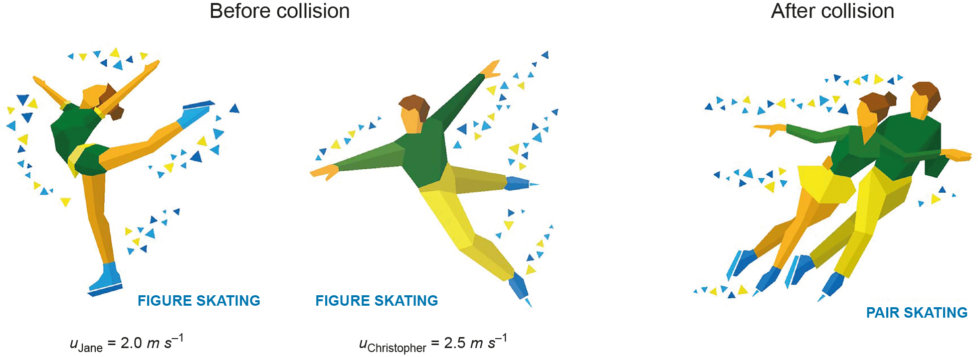

Use the principal of conservation of momentum to determine Jane and Christopher's velocity after their collision. (Velocity is a vector quanity, so remember to take this into account when performing your calculations!)

|  |
| --- |
|  |
|  |
|  |
|  |

Student worksheet

7.8 Work occurs when an object is moved or rearranged. Energy can be calculated

Pages 170–171

Work, kinetic energy, gravitational potential energy and elastic potential energy

1 Complete the table by defining the key terms.

|  |  |
| --- | --- |
| Term | Definition |
| Work |  |
| Kinetic energy |  |
| Gravitational potential energy |  |
| Elastic potential energy |  |

2 Complete the flow chart below that shows the energy transformations (work) for a bouncy ball falling to the ground and bouncing back up again. Where necessary, use g = 9.80 m s–2. Converting units: 1000 joules (J) = 1 kilojoule (kJ).



3 How much work has to be been done on a stationary car of mass 1800 kg to get it travelling at a speed of 110 km h–1?

A 0 J

B 2.8 × 104 J

C 9.9 × 104 J

D 8.4 × 105 J

E 1.1 × 107 J

|  |
| --- |
|  |

4 Without changing its mass, what effect will decreasing an object’s speed from 15.0 m s–1 to 5.0 m s–1 have on its kinetic energy?

A Its kinetic energy will remain unchanged.

B Its kinetic energy will be a third of what it was initially.

C Its kinetic energy will decrease by a factor of nine.

D Its kinetic energy will increase by a factor of nine.

E Its change in kinetic energy cannot be determined from the information provided.

|  |
| --- |
|  |

5How much gravitational potential energy does a 250-g kite have if it is hovering 30 m above the ground?

A 0 J

B 73.5 J

C 735 J

D 73.5 kJ

E 73 500 kJ

|  |
| --- |
|  |

Extend your understanding

6 Figure 2 shows a toy gun. Inside the gun, there is a spring that is compressed a total distance of 5.0 cm by pushing a suction-capped dart into its barrel. Figure 3 shows a graph of the spring’s force (N) against compression distance (m).

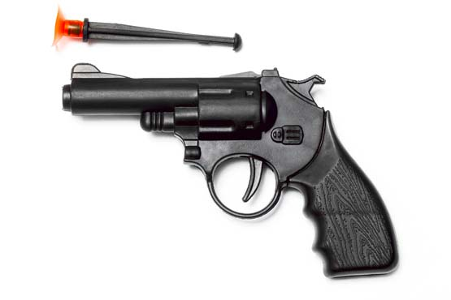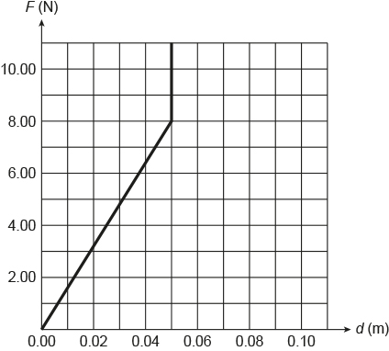

The energy stored in a spring can be determined by calculating the area underneath its force (N) against extension (m) graph.

How much energy is stored in the spring when it is compressed by 5.0 cm?

|  |
| --- |
|  |
|  |
|  |

Student worksheet

7.9 Energy is always conserved

Pages 172–173

Conservation of energy

1 What is the law of conservation of energy?

|  |
| --- |
|  |

2 Which two types of energy are harnessed by a pendulum?

|  |
| --- |
|  |

A student of mass 60.0 kg went bungee jumping during her holidays. The bridge from which she jumped was 250 m above a river. She was attached to a bungee cord that had an unstretched length of 150 m. You can assume that the student and the bungee cord are part of an ideal energy-conversion system. This means that no energy is 'lost' to the environment as heat or sound.

Figure A shows the student just before she jumps off the bridge.

Figure B shows the student a short time later when she has fallen a distance equal to the unstretched length of the bungee cord.

And Figure C shows the student when the bungee cord has reached its maximum length and the student is momentarily stationary.

|  |  |  |
| --- | --- | --- |
| SW0739_01095 | SW0740_01095 | SW0741_01095 |
| **A** | **B** | **C** |

3 At which point is the bungee jumper likely to experience the most kinetic energy?

|  |
| --- |
|  |

4 At which point is the bungee jumper likely to experience the most elastic energy?

|  |
| --- |
|  |

5 What was the student’s gravitational potential energy at point A as shown in Figure 1? Provide your answer in joules. (Remember: GPE = mass × gravity × height)

|  |
| --- |
|  |
|  |
|  |
|  |

6 How much elastic potential energy is stored in the bungee cord when the student has fallen 180 m and reached point C as shown in Figure 3? Give your answer in joules.

|  |
| --- |
|  |
|  |
|  |
|  |

Extend your understanding

A pendulum, as shown in Figure 4, is known to have an efficiency of 95% on each swing.

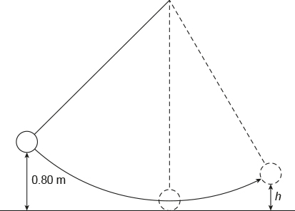

Figure 4

7 To what height, h, would the pendulum bob rise after a single swing if it was being released from a height of 0.80 m as shown? Give your answer in metres.

|  |
| --- |
|  |
|  |
|  |
|  |

8 How far below its release height of 0.80 m would the pendulum bob be after its return swing? Give your answer in metres.

|  |
| --- |
|  |
|  |
|  |
|  |

Student worksheet

7.10 Car safety features requires an understanding of Newton's laws and momentum

Pages 174–175

Newton's laws and car safety features

While out driving in his car, Harry went around a corner too quickly, lost control of his car and ran off the road, colliding with a tree. His friend Ash was beside him in the passenger seat. Both men were wearing seatbelts. The car was travelling at a speed of 54 km h–1 when it hit the tree.

Unfortunately, Ash’s airbag malfunctioned and did not deploy while Harry’s airbag did deploy. Because of this, the time for each of their heads to come to a stop was different. Ash’s head collided with the dashboard and took 0.012 s to come to a stop. Harry’s head collided with the airbag and took 0.060 s to come to a stop.

The mass of Harry’s head was 5.0 kg, the same as Ash’s head.

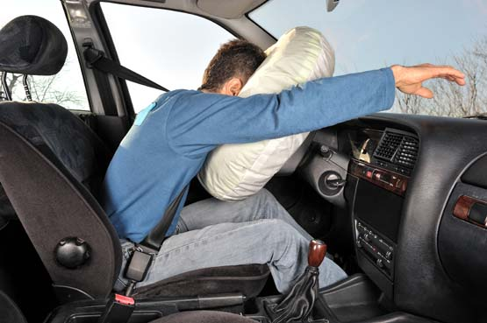

1 What safety features were supposedly in place in Harry’s car?

|  |
| --- |
|  |
|  |

2 How does an airbag work?

|  |
| --- |
|  |
|  |
|  |

3 Describe one other safety feature that might have helped to keep Harry and Ash safe?

|  |
| --- |
|  |
|  |

4 What was the initial speed of each man’s head at the start of the collision? Give your answer in metres per second.

|  |
| --- |
|  |
|  |
|  |

5 Calculate the acceleration experienced by Harry’s head and that of Ash during their respective collisions. Give your answer in metres per second per second to the nearest whole number.

|  |  |
| --- | --- |
| Harry | Ash |

6 Calculate the average force experienced by each of Harry and Ash's heads during their respective collisions. Give your answer in newtons to the nearest whole number.

|  |  |
| --- | --- |
| Harry | Ash |

7 Based upon your calculations, what conclusions can be drawn about the relationship between the average stopping force on an object and the collision time?

|  |
| --- |
|  |
|  |
|  |

Extend your understanding

8 Use your understanding of Newton’s three laws to describe the motion of, and the forces acting upon, Harry’s head during the car’s collision with the tree.

|  |
| --- |
|  |
|  |
|  |
|  |
|  |
|  |
|  |
|  |
|  |